MONSTERBALL: iPhone
Game Design Document

“Smash the Opponents – literally!”

Version: 1.2.1
2/02/11

Scott Easley
St.John Colón
Matthew Arnold

Table of Contents
Pitch 3
Core Design 3
Team construction 4
Moves and Controls 4
Game Flow 5
Offense 5
Defense 5
Tackling 6
Running into a player 6
Punch / Spin 7
tackle / jump 8
Whammy Meter 9
Quarterback Abilities 10
Whammys 10
Halftime minigame 10
Different Modes 11
Season / playoff 11
Game progression 11
Team Progression / REWARDS 11
teams 12
Player Types 13
QB/heroes 16
Quarterback Abilities 16
Hazards 19
Fields 20

Concept

Pitch
Monsters, aliens, robots and mutants face each other; 11 vs 11. A football is the only thing keeping the two sides apart. The crowd full of punks and gore-lovers cheer in the few remaining stands on this fiery hell pit. Molten crevices cut through the sidelines ready to consume any wide receiver who doesn’t watch his step. Fiery pits and land mines are haphazardly scattered on the field ready to give the crowd what they want – death.
When the ball is hiked, the defensive line ruthlessly begin throwing punches trying to get to the quarterback. The half back fakes a grab for the ball, but accidentally runs into a landmine. He explodes, taking a tight end, who was looking for some QB blood, along with him. A wide receiver jumpers over a safety and calls for the ball. The QB attaches dynamite to the ball and throws. As soon the alien receiver catches the ball, it begins throwing a storm of dynamite behind him, covering his tracks. Defensive men explode left and right. The receiver is distracted enough to almost miss the fiery pit right in front of him, but sees it just in time to jump it. Inches away from the endzone the Alien dives; Dives right into an invisible safety who brings his first full force into the unlucky receivers head. 1st and Goal.
This is the way only mutants play football; the way humans, too concerned with their lives, would never play. It is the best way to play football.

Core Design
Mutant League is a remake of sorts of the EA Genesis title by the same name. It will retain many of the same elements of that game.
- Simplified football gameplay still intact
- Combative gameplay on the field
- Mutant team version of professional football teams
- Hazard filled fields
- Various special moves in the forms of Whammys
- Halftime Minigame
- Multiplier (possible)
The game will flesh out the modes, providing a lengthier campaign and playoff mode. There will also be different hazards and Whammys than the original game.
Controls will be simplified for the iphone. It will take from the HUD and control scheme from EA’s Madden on the iPhone.
Combative gameplay will take more from Sega Soccer Slam than the Genesis game. Instead of 3 moves that seem to vary in success, Mutant League iPhone will follow a simpler, rock, paper, scissors style move set from Soccer Slam.
- Jumps beat dives
- Spins beat punches
There will also be RPG elements, making the QB into a hero similar to DOTA games such as League of Legends.
- QB has various stats that are upgraded throughout the season
- Different QB’s have different default Whammys
- Learn new Whammys and gain new players as you progress through the season

Gameplay

Team construction
Teams are of 7 players each.
Offense
1 Quarterback
3 Offensive linemen
1 Running Back
2 Receivers

Defense
3 Safeties
2 Tight ends
3 Linemen

Moves and Controls
Thumbstick – movement
Left Button – Jump / Tackle
Right Button – Spin / Punch
Whammys – Whammy Button

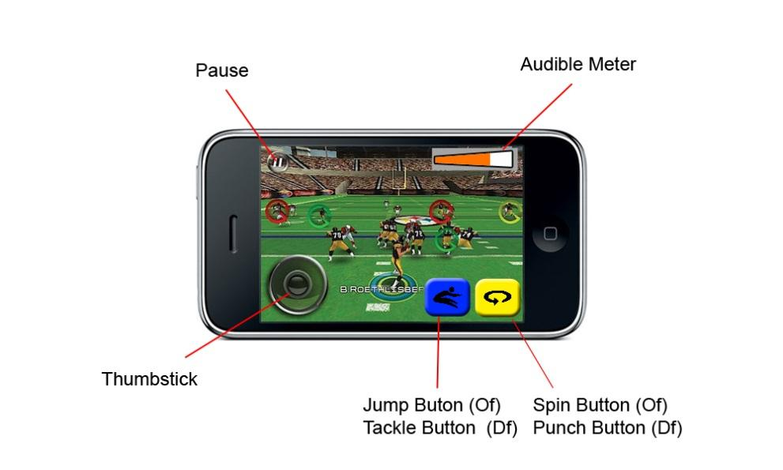

Game Flow
- Select Game Mode
- Select Team
- Coin Toss
  - Coin toss screen where the player either chooses heads/tails, or flips the coin. Upon winning, they choose to receive or defend.
- Select Play
- Before the play begins, the player may choose a Whammy if they have the Whammy meter full.

Offense
- Hike the Ball
  - Simply pressing back on the thumbstick will hike the ball.
- Run or Pass
  - RUN: play will have the QB automatically hand the ball to the HB. The player then has control of the HB
  - PASS: This will work like Madden on iPhone. Possible passers will have a icon appear over them. They icon will change color based on how open they are. Tapping the icon than passes to that player.
    - As the ball is in the air, the player will gain control of the selected receiver.

Defense
- Select player before the ball is hiked by tapping on any available player
  - Movement is restricted until the ball is hiked. It’s not worth the player constantly getting offsides.
- Move selected player to try to take the ball
  - I do not think you should be able to switch players. I think its best that if there is any pass or run we have a system where the computer automatically changes you to the closest player, ala Madden
- Either tackle or punch the player

Move Break Down

Tackling
When two players hit they engage in a tackle event. There are essentially three moves each side can do.
- Simply run into the player
- Engage a punch/spin
- Engage a jump/tackle
Let’s break down how these work.

Running into a player
- Success dependent on variables
- Damage dependent on position.
Running into a player works like a normal tackle in a football game. The players animate automatically in the way that seems natural.
Ball Carrier: Tries to shrug off the offense, or bounces off of them depending on the trajectory.
Attacker: Shoulder down into the player
The success of running into the ball carrier depends on a combination of tackle, tackle break, run block, angle, and luck.
Angle and Luck can be explained in the diagram below. It essentially breaks down to a frontal attack should be near certain tackle. Attacking from the back will depend most on momentum, and the sides will be broken down by glances and full on hits.
- Tackle: adds % to the base % seen below
- Run Block: if the player is a D linemen, than this % is also added
- Tackle Break: Tackle Break decreases the % block
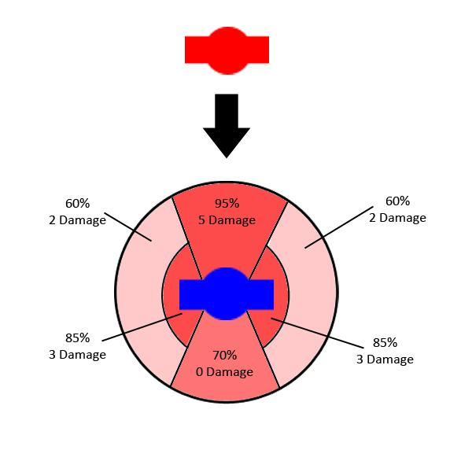

Punch / Spin
These moves (punch/spin and tackle/jump) are simple rock paper scissors mechanics. One cancels out the others.
If the defender punches it is a guaranteed hit. However, if the ball carrier spins at the right time, it deflects the punch.
To prevent these from being spammed (as they add a negative multiplier to tackle chances) the ball carrier should be completely vulnerable for a time after performing a move. So A few frames after a spin or a jump, all tackle percentages are 100% for the offender, and damage should be increased.
Punch on Hit
- 85% chance of tackle (should be the same % as a side hit)
- 15 Damage
Spin on hit
- 100% chance to stop punch
- .5 Multiplier against Tackle chances
- 5 Damage against offender

tackle / jump
Tackle on Hit
- 100% chance of tackle
- 5 damage
Jump on Success
- 100% chance to stop tackle
- .5 Multiplier against tackle chances
Note: All of these percentages and numbers are rough estimates. Football is a game of very careful balance between offense and defense. These variables should be easily changed on the fly so we can balance it.

Catching

Receiving
Calculated using these variables:
- Length of Throw (LT)
- QB Accuracy (Acc)
- Hands (H)
- Distance from Defender (Blk)
(Acc/LT) x (H) x (1/Blk)
Essentially this creates three percentages that decrease the likelihood of the catch.
(Acc/LT) = Accuracy should decrease with distance. This is the likelihood the ball even gets to a spot the player can catch/
(H) = Likelihood the player catches it
(1/Blk) = The closer the defender, the greater chance they block it. If 2 defenders are in range, then their distance is simply added, making it even more likely to be blocked.

Interception
If the (1/Blk) is successful, and the player does indeed block the pass, there is then a calculation to run if the pass is actually intercepted.
Blk + H
Simply put, the farther the defender is from the receiver provides a number, and their defender’s Hands stat adds to that number.
The reasoning behind this is, if the defending blocked the ball, the farther away they are from the receiver the more likely it as a poor pass. As in – the defender is more open as well, and so it is easier to catch

Abilities

Whammy Meter
The Whammy Meter is located on the top right of the screen. It will build as he game goes on based on how well you are doing. This is very similar to Sega Soccer Slam. Suggestions of what can add to the meter
- Successful catch
- Every yard gained
- First down
- Successful punch/spin
- Successful tackle/jump
- Avoiding being tackled
- Threading the needle
- Multiple successes in a row (multiple 1st downs, multiple catches, etc)
- Causing a fumble
- Intercepting
You get the point. We can figure out what all we can track, but almost everything should add to the meter. This way, its not just doing well, but HOW you do well. Style matters.
Completing big achievements should have a visual feedback (similar to NFL Street). Text that appears plus the score being added to the Whammy Meter.

THREAD THE NEEDLE!
+400

The Whammy meter can be used for two things
- Whammys before the hike
- QB abilities
Tapping the meter used these abilities.
THE WHAMMY METER FILLS UP AT 10,000

Quarterback Abilities
Depending on which quarterback the player chooses, their ability takes up a certain amount of the meter. This should be marked by an icon along the meter.
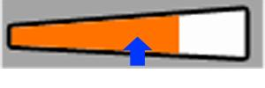
NOTE: This art is just an example. Suggestion is to make the meter look as unlike this example as possible.

Whammys
When the Whammy meter is full, the player will be able to tap on it and bring up the Whammy meter. The Whammy meter will present 4 options for both defense and offense.
Using the Whammy empties the entire meter.
There should be an indicator if the other team is going to use a Whammy.
Offensive Whammys
Confusion | The other team’s controls are reversed for a few moments
Bomb Attack | The ball turns into a bomb, and the Center throws it into the middle of the defense. It explodes providing ample damage to the whole team. This doesn’t count as a down or a possession. You simply redo the play.
Rocket Jump | The Running Back gets the ball and can fly 20 yards. The player controls the jet pack. The danger of this is if the defense can be where the Running Back lands, he will explode, and get an incomplete and perhaps a fumble.
Super Strength | Your whole team gets a major strength boost (they should increase in size) making it hard to tackle or get by them. Great for returns.

Defensive Whammys
Invisibility | Your team turns invisible to the other team. They will appear as ghosts to you.
QB Smash | This will send all your players on fire into the QB to attempt to give as much damage as possible.
Magnet Player | The player of your choosing will become electrified. If you get that player close to the ball carrier, it will instantly steal the ball from the player, resulting in a fumble.
Super Speed | Your team turns very fast and can jump very high. Great for blocking punts and field goals.

Halftime minigame
At halftime there will be a simple shooting minigame. This game should level up slightly as you progress through the game and season.
WILL FLESH THIS OUT LATER
It should be similar to the minigame in the original Mutant League. The player throws explosive footballs at the halftime entertainment. The player tries to blow up the entire marching band.
There should be some bonus for completing the halftime game. It could be experience, or perhaps filling some of the Whammy meter.

Modes

Different Modes
There will be a series of gameplay modes available at the front menu.
- Quick Play: Play a mode with your own settings.
  - Half Time Length: 2,4,6,8,10
  - Health: Invincible, Strong, Human, Weakling, Glass
  - Field: Choose which field
  - Hazards: None, Death Zone, Annihilation
- Practice: Play a single play at a time, always starting at the 50 yard line.
  - Offense
  - Defense
- Season: Play a full season with the same team and quarterback
- Playoffs: Play 4 games with the same team and quarterback
- Multiplayer: Play a quick game match online (this may obviously be excluded if we can’t do it)

Season / playoff

Game progression
Playoffs are essentially a short campaign. It is only the final 4 games of the season, and your team doesn’t continue. It’s a onetime shot.
Season consists of a normal football season.
- 14 games
  - 3 games vs. each of the other 3 teams in division (6 games)
  - 4 games against the other division in your conference (4 games)
  - 4 games against 4 teams in the other division
  - NOTE: We will skip out playing the same ranked teams in your divisions since we only have 2 divisions per conference.
- 16 team play off
  - 4 games (Round of 16, Quarter finals, semi-finals, finals)

Team Progression / REWARDS
Season and Playoffs are where you can level up your quarterback. Wins provide more experience points. When a QB gains a level he can spend skill points on his 4 variables.
Playing through Season is where you can get special unlockables.
- All star teams
- New fields
- New quarterbacks
Unlockables are all suggestions

Teams and players

teams
In the tradition of the original game, teams should be spoofs of professional NFL teams. We will do 16 teams instead of 32. It also allows us to add teams for DLC or updates
Teams could be simply quantified by 3 variables
Damage: Calculated from Health and Wounding
Strength: Calculated from Pass/Run Blocking and Tackle
Skill: Calculated from Hands, Tackle Breaking
Speed: Calculated from team’s aggregate Speed
Note: These apply to the averages of the team. They should be calculated based on what sort of monsters make up each team. The numbers below are just for example.

Team | Home Field | Skill | Strength | Damage | Speed
Mutant Conference
Murder Squad | Sewer | 4 | 1 | 5 | 4
New Puke Freaks | Asteroid | 5 | 4 | 4 | 2
Clever Killers | Volcano | 3 | 3 | 2 | 5
Bullet Dodgers | Hellmouth | 1 | 2 | 3 | 5
Slayville Slayers | Apocalypse | 2 | 2 | 5 | 3
Termination Terrors | Comet | 5 | 5 | 4 | 1
Panic Psychos | Glacier | 3 | 2 | 4 | 4
Sesmic Schizios | Graveyard | 3 | 4 | 2 | 4
Noxious League
Alien Cowboys | Comet | 5 | 5 | 2 | 3
Sick Spewers | Sewer | 4 | 4 | 3 | 3
Vile Villains | Apocalypse | 2 | 4 | 1 | 5
Cruel Demons | Hellmouth | 1 | 5 | 4 | 1
Crazed Criminals | Graveyard | 5 | 1 | 4 | 5
Screwy Bashers | Volcano | 4 | 3 | 3 | 4
Wicked Warriors | Asteroid | 3 | 5 | 3 | 3
Manic Monsters | Glacier | 2 | 3 | 4 | 3
Quarterbacks: Perhaps each team will probably have a default quarterback for quick play -- If the menu can be constructed to easily select a QB, then perhaps that route.

Player Types
Each type of player has 4 stats. Health and Speed are used by every player. The other two are specific to position.
There will be three types of monsters per position pair. If your player dies, you will be forced to use a reserve. I think it would be funny if all reserve players look the same, no matter the position. Just a sad lonely peon.
Red Stats are for offensive
Blue stats are for defensive.
Not sure which monsters we will be using. But essentially, there will be 3 types of each position pair. We can reduce this to two types if needed.

Quarter Backs
Explained in their own section. There are 4 quarterbacks, which are separate from the teams. They have their own stats.

O Line / D Line
Big Monster #1
- Health: 5
- Speed: 1
- Pass Block: 3
- Run Block: 5
- Tackle: 5
- Wounding: 5
Big Monster #2
- Health: 4
- Speed: 2
- Pass Block: 5
- Run Block: 3
- Tackle: 4
- Wounding: 4
Big Monster #3
- Health: 4
- Speed: 1
- Pass Block: 2
- Run Block: 4
- Tackle: 4
- Wounding: 5
Reserve
- Health: 3
- Speed: 1
- Pass Block: 1
- Run Block: 2
- Tackle: 3
- Wounding: 1

HB / Tight end
Medium Monster #1
- Health: 4
- Speed: 3
- Hands: 5
- Tackle Break: 3
- Tackle: 4
- Wounding: 4
Medium Monster #2
- Health: 3
- Speed: 4
- Hands: 4
- Tackle Break: 5
- Tackle: 3
- Wounding: 3
Medium Monster #3
- Health: 3
- Speed: 3
- Hands: 3
- Tackle Break: 3
- Tackle: 3
- Wounding: 2
Reserve
- Health: 2
- Speed: 2
- Hands: 1
- Tackle Break: 2
- Tackle: 2
- Wounding: 1

WR / Defensive backs
Tall Fast Monster #1
- Health: 1
- Speed: 5
- Hands: 5
- Tackle Break: 3
- Tackle: 2
- Wounding: 2
Tall Fast Monster #2
- Health: 2
- Speed: 4
- Hands: 4
- Tackle Break: 4
- Tackle: 4
- Wounding: 2
Tall Fast Monster #3
- Health: 2
- Speed: 4
- Hands: 3
- Tackle Break: 2
- Tackle: 3
- Wounding: 1
Reserve
- Health: 1
- Speed:3
- Hands: 2
- Tackle Break: 2
- Tackle: 1
- Wounding: 1
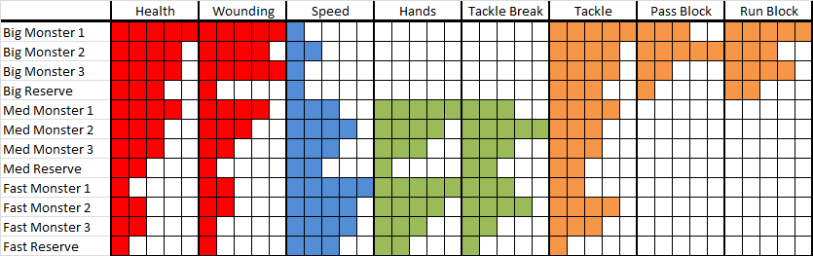

QB/heroes
Quarterbacks will act sort of like heroes in DOTA games such as League of Legends and Defense of the Ancients.
Quarterbacks are separate from teams. Upon choosing a team the player will then choose a quarterback.
Quarterbacks have three variables
- Speed: How fast the QB runs
- Accuracy: How accurate the passes are, and how likely the Receiver will catch it
- Strength: How difficult it Is to sack/tackle the QB
The QB also each have a unique ability the player can use separately from the Whammy.
Quarterbacks level up (to level 20) . You spend those points on those 3 variables, plus the strength of the ability.
Quarterback | Ability | Speed | Accuracy | Strength
Rock Mason | Rock: Turn invincible but still | 1 | 4 | 5
Big McHuge | Engulf: Damage all who touch you | 3 | 3 | 4
Sludge Thunder | Thunder Charge: Run very fast | 5 | 2 | 3
Jack Hammer | Fast Ball: 100% catch | 2 | 5 | 3

Quarterback Abilities
Abilities explained in a bit more detail and how they level up.
Abilities are used once the ball is hiked. The “Whammy meter” also acts as the meter to use these moves.
The player than as a choice, wait for the Whammy meter to get 100% so that they can use the Whammy. Or use up the meter on the QB moves. They will have to use the meter strategically in order to win.
Rock (33% meter): When you play rock, the QB can’t move, but is invincible to being touched. Great for getting a pass.
- Each level increases the amount of time you stay rock. 2s -6s
Engulf (50% meter): Engulf turns the QB into a flaming creature. Anything which touches it takes damage.
- Each level increases the amount of damage given
Thunder Charge (70% meter): QB runs super fast, and his jump move increases drastically.
- Each level slightly increases speed and jump distance.
Fast Ball (100% meter): The receiver is guaranteed to catch the ball.
- Not sure what should increase. I am thinking it could be less % required to use it. Or perhaps the receiver gains a certain amount of invulnerability. Or the ball damages players around the receiver. Not sure.

Leveling up
Abilities: Each ability can be leveled up 4 times. They start at level 1, and max out at level 5.
Stats: QB stats are not related to the teams, so there is no team multiplier applied to the numbers. Their stats go from 1-10
Gaining EXP:
The QB gains XP from the Whammy meter and by finishing a game. When finishing a game, the EXP will read as follows:
Performance!: Total Whammy Meter accumulated / 100
Whammy meter will fill up at 10000. That way the points feel big while playing, but obviously that number is too large for EXP
Victory!: 100 + # of Points Scored + point differential*2
A victory of 20-7 would yield: 100 + 20 + (13*2) = 146
OR
Loss!: # of Points Scored
Level up based on the idea that the average EXP earned per game is 300 (33% chance of losing with a score of 20, and 66% chance of winning with a score of 20-7, and average Whammy meter being filled up twice[200 points])
Level | EXP Needed | Total EXP | Avg # of games
1 | - | - | 0
2 | 200 | 200 | 1
3 | 300 | 500 | 2
4 | 400 | 900 | 3
5 | 500 | 1400 | 5
6 | 600 | 2000 | 7
7 | 750 | 2750 | 9
8 | 900 | 3650 | 12
9 | 1050 | 4700 | 16
10 | 1200 | 5900 | 20
11 | 1350 | 7250 | 24
12 | 1550 | 8800 | 29
13 | 1750 | 10550 | 35
14 | 1950 | 12500 | 42
15 | 2150 | 14650 | 49
16 | 2350 | 17000 | 57
17 | 2600 | 19600 | 65
18 | 2850 | 22450 | 75
19 | 3000 | 25450 | 85
20 | 3500 | 28950 | 97

Stats / Variables

Players
For players, these variables are
- Health: 100 (+0,10,20,30,40)
- Speed: Speed will be broken up into top speed, and acceleration.
  - Top Speed: Player at full sprint
    - 5 meters per second + (0%, 12%, 25%, 37%, 50%)
  - Acceleration: How fast it takes to go from standing to top speed. This should follow a standard acceleration curve.
    - Base acceleration should reach top speed at .5 seconds
      - This will be useful for catching the ball, where the receiver has to stop to catch, and then accelerate
- Wounding: Simple addition of number to the base damage give (0,1,2,3,4)
- Hands: How likely the player will catch the ball, or fumble on a tackle
  - Catching: adds % to base catching % of 90. (+1%, +2%, +4%, +6%, +8%)
  - Fumble: detracts from fumble % of 5% (-.2%, -.5%, -1%, -1.5%, -2%)
- Tackle Break: Decreased the tackle percent (-1%, -3%, -6%, -9%, -12%)
- Tackle: Adds to the tackle percent (+2%, +4%, +6%, +8%, +10%)
- Pass Block: This is for calculating the chances of tipping a throw (+1%, +2%, +3%, +4%, +5%
  - Calculation will be based on height of throw, distance the defender is from QB, and then their Pass Block multiplier will add a % to that.
- Run Block: This adds yet more to the tackle percentage, while adding to the fumble percentage as well
  - Tackle: (+.5%, +1%, +1.5%, +2%, +2.5%)
  - Fumble: (+.2%, +.5%, +1.2%, +1.5%, +2%)
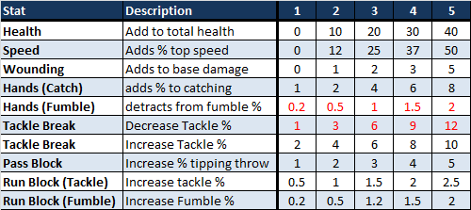

Fields

Hazards
These are mostly taken directly from mutant league for now (highlighted in yellow). We should/will add more, as well as remove some.
Hazards | Description | Damage
Rocks | Somewhat large rocks, often found in pairs or trios, will cause a player to fall on his face. A ball carrier who falls over a rock will not be down until an opposing player touches him. | 0
Grave | Acts like a rock | 0
Pits | Holes in the field that you can fall in. This will not cause damage  to any player, but it will cause the play to end if the ball carrier falls in.  Multiple players can fall into the same put, but all players are removed from  pits after the play. | 3
Ghoul Pit | A pit with hands that come out and destroys the player. | 5
Sewer Cap | A sewer cap that if stepped on the player falls through, and a nice big splash of green sludge rises up. | 3
Fire Pits | Similar to a pit, with one deadly side effect. They are filled  with lava which will kill any player who falls into them. The play will end  if the ball carrier falls into a fire pit. | 10
Thin Ice | Similar to a pit, with one deadly side effect. They are filled  with lava which will kill any player who falls into them. The play will end  if the ball carrier falls into a fire pit. | 5
Abyss | Missing portions of a field in out space fields. If a player runs  over this gap he will be blown into outer space. The play will end if he has  the ball. Players who go into the abyss will return the next play and receive  no damage for doing so. Players may jump, spin jump, or dive over abyss  areas rather than running around them. | 0
Mines | There are two types of land mines. One looks like a bomb and the  other looks like a land mine. Both will kill the player who steps on them.  A ball carrier who is killed by a mine will fumble the football. Mines come  back at the end of the half. After a mine is detonated, it will leave a pit  or fire pit. | 15
Bombs | Like the mine, but has a big blast radius that hurts those around as well. | 15 (slpash damage)
Ice | A patch of ice that is slippery, making it hard to turn or stop. | 0
Sludge | Acts like ice | 0

Fields
The fields will each contain a certain amount of hazards and gaps in the field. Each team has a home field that will be played if they are the home team.
What hazards will be on what field are just placeholder for now, until we get a better grasp on what the hazards will be.
Field | Description | Hazards
Sewer | A green, toxic, concrete field. Sludge on the sides | Sludge, pits, bombs
Asteroid | Rock field in space. Lots of abyss. Ice as well | Abyss, pits, landmines
Volcano | Inside a volcano. Black rock, fire everywhere. | Fiery pits, lava, bombs, rocks
Hellmouth | Like the volcano, but also with graves. Normal rock instead of black rock. | Graves, fiery pits,
Apocalypse | A desolate city. A fiery car or so, and sewer caps you can fall in. | Fiery cars, sewer caps, landmines
Comet | Like the asteroid but with fire. | Ice, fiery pits, abyss
Glacier | Icey field with slippery spots and thin ice. Gashes of water on the side. | Ice, thin ice
Graveyard | Grass field in a cemetery. | Graves, landmines, pits

